- Purpose

The purpose of this procedure is to ensure correct calibration of the Hayssen Bagger for proper operation.

- Scope

This procedure applies to all finished 50-lb products produced at the Manufacturing facility.

- Responsibility

Lead Operator and/or Process Operator

- Safety Considerations

All safety glasses and appropriate safety apparel is to be worn at all times.

Safety is a condition of employment. Employees are not authorized to work in an unsafe manner and are prohibited from harming the environment of the facility or community.

- Materials/Equipment

- 21 lb weight

- Procedure

Calibration of the machine is necessary for proper operation. The goal is to provide the customer with consistent weights (+/- 0.5 lbs. for 50-lb bags) for their product. This strict standard allows Giles to maintain a reputation for a quality finished product to its customers.

  - Stop the bagger and clean the scales. See cleaning procedure.
  - From the WeighPack software screens, select the Diagnostics screen.

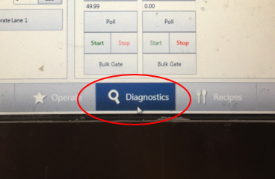

  - Select the line to calibrate

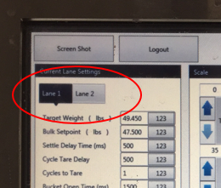

  - Press the ‘Full Calibrate’ button

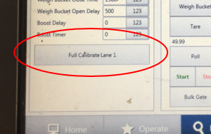
  - Follow the on screen prompts
  - When instructed, enter 21 pounds into the scale as the standard weight
  - When instructed, hook the 21 pound weight

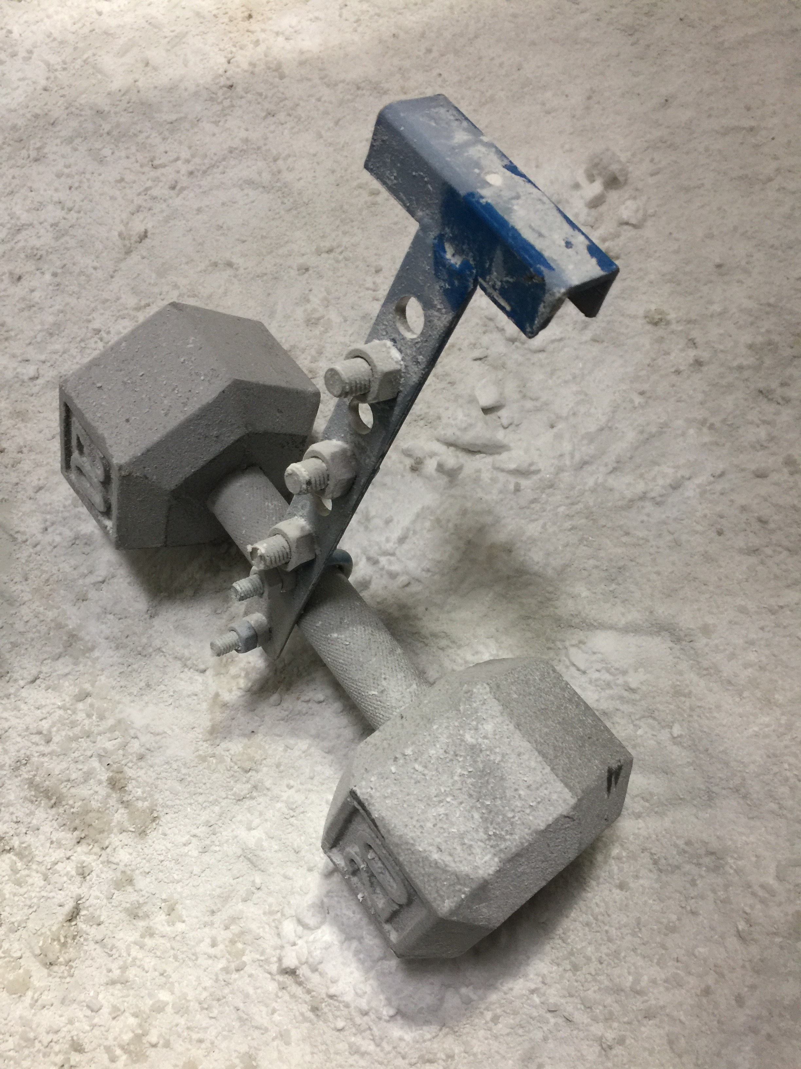

Over the side of the bucket on the line being calibrated

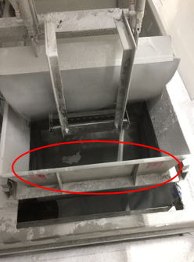

  - The scale will complete the calibration, and save the data.

- Reference Documents

N/A

- Change Information

- Changed the document owner
- Updated the calibration procedure to reflect the WeighPack software algorithm

